**Docker Exercise**

**Problem**: In CICD concept we need to build docker image. As we are working on microservices we need to aware of three different type of building docker image.

1. Build a Docker image using docker file.

**-** Dockerfile

FROM openjdk:19-jdk-alpine3.16

ARG JAR_FILE=target/hello-world-0.0.1-SNAPSHOT.jar

ADD ${JAR_FILE} app.jar

EXPOSE 8080

ENTRYPOINT [ "java","-jar","/app.jar" ]

**-** Console output

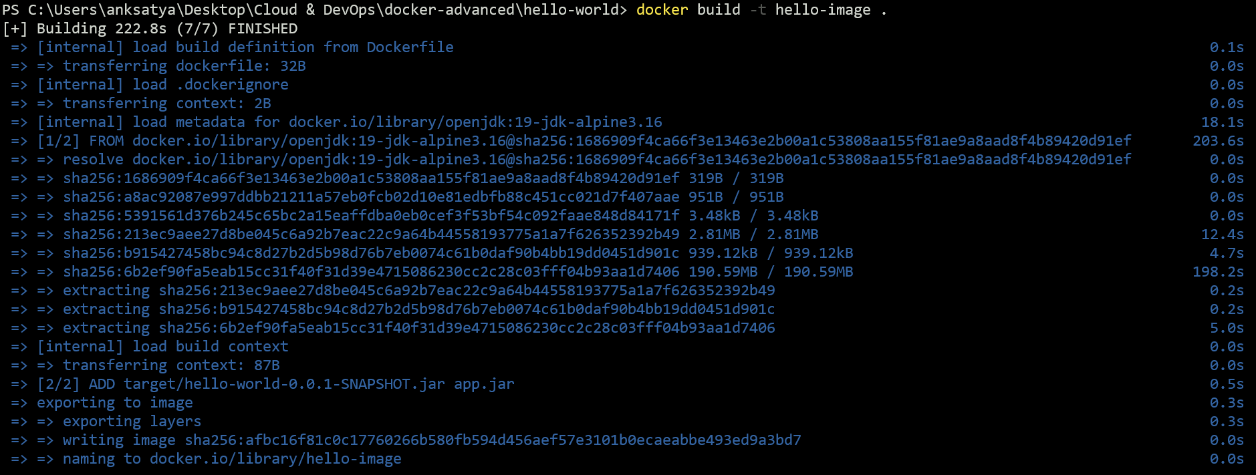







2. Build an OCI image from source code with Cloud-Native Build Pack.

**-** plugin for creating image using cloud native build pack.

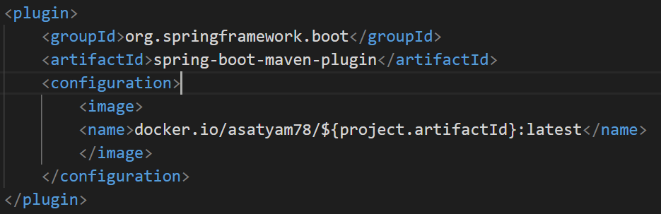

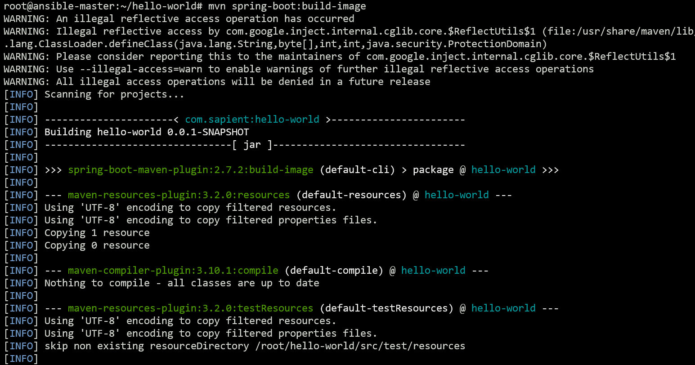

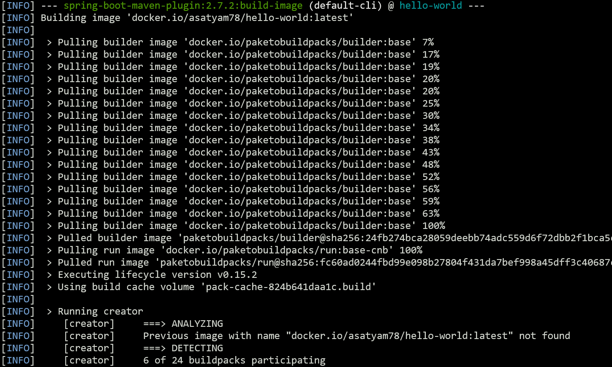

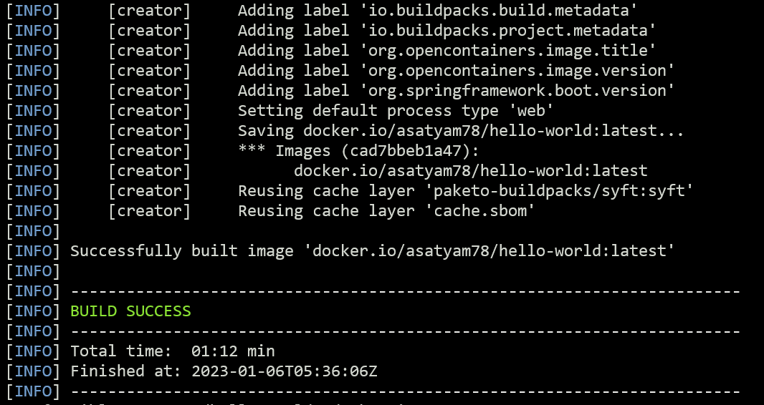

3. Optimized the image at runtime by splitting part of JAR into different layers using layer tools.

**-** docker.layer

FROM adoptopenjdk:latest as builder

WORKDIR application

ARG JAR_FILE=target/*.jar

COPY ${JAR_FILE} application.jar

RUN java -Djarmode=layertools -jar application.jar extract

FROM  adoptopenjdk:latest

WORKDIR application

COPY --from=builder application/dependencies/ ./

COPY --from=builder application/snapshot-dependencies/ ./

COPY --from=builder application/application/ ./

ENTRYPOINT ["java","org.springframework.boot.loader.JarLuncher"]

**-** Console Output

